Hydrodynamic constraints during early life stages of marine fishes
Student name: Victor China
Supervisor: Dr. Roi Holzman
Institute: Tel-Aviv University
My research offers a novel approach to the study of early life stages in marine fishes. I hypothesize that hydrodynamic limitations play a crucial role in the selective process that these fishes undergo during the egg, larval, and recruitment stages. I believe that my study can offer new and important insights in two main fields: ecology, and the mariculture industry of marine fishes.

Larval fishes suffer prodigious mortality rates, eliminating 99% of the brood within a few days after first feeding. Hjort (1914) attributed this “critical period” of low survival to the larvae’s inability to obtain sufficient food. Such a high mortality rate may imply the existence of constraints, possibly from an earlier life-history stage. Although the “critical period” is well described, the mechanisms behind it are unclear.
In my study, I will focus on three major life-history stages, each of which has critical consequences for survival: egg, first feeding, and settlement. My working hypothesis is that hydrodynamic constraints play an important role in limiting the maximal egg size, due to oxygen diffusion limitations, which may be overcome through flow speed around the egg (fig 1). Small eggs limit the maximal size of newly-hatched larvae which, in turn, experience a viscous hydrodynamic regime. This regime limits larval ability to capture prey using mouth suction. I further hypothesize that the low survival of larvae will result in stochastic survival, leading to high phenotypic variation among individuals and cohorts at settlement. Upon settling, directional selection should rapidly reduce the variance in morphological components related to anti-predation mechanisms. A comparison of the variance between and within newly recruited cohorts and post-settlement juveniles may shed light on the nature of the selective processes experienced during the pelagic larval period.
My study combines theoretical hydrodynamic models with comparative experimental work enabling allow me to explicitly test the role of hydrodynamics in constraining performance and survival during early life stages in fish.
My major findings to date are centered on the hydrodynamic constraints experienced during the larval stage. Most of my results have already been published under the title “Hydrodynamic starvation in first-feeding larval fishes” (China V. & Holzman R 2014). To summarize: I found that hydrodynamic constraints on the ubiquitous suction mechanism (movies 1 2 3) in first-feeding larvae limit their ability to capture prey, thereby reducing their feeding rates. I found that the feeding efficiency of younger larvae is lower than that of their adult counterparts (fig 2). To separate between the role of ontogeny and hydrodynamics I conducted dynamic-scaling experiments (fig 3) and found that larval size is the primary determinant of feeding rate, independent of other ontogenetic effects (fig 4). I concluded that first-feeding larvae experience “hydrodynamic starvation,” in which low Reynolds numbers mechanistically limit larval feeding performance and kinematics (fig 5 & fig 6), even under high prey densities. These findings provide a hydrodynamic perspective on feeding of larval fishes, focusing on the physical properties of the larvae and prey rather than on prey concentration and rate of encounters. Furthermore, my as yet unpublished data also suggest that feeding performance is directly affected by the Re environment experienced by the larvae while feeding (fig 7); and that the main component that differentiates between failure and success of a feeding attempt (for a given larval age) is that of normalized prey capture distance (fig 8).
China, V., & Holzman, R. (2014). Hydrodynamic starvation in first-feeding larval fishes. Proceedings of the National Academy of Sciences, 111(22), 8083-8088.
Figures:
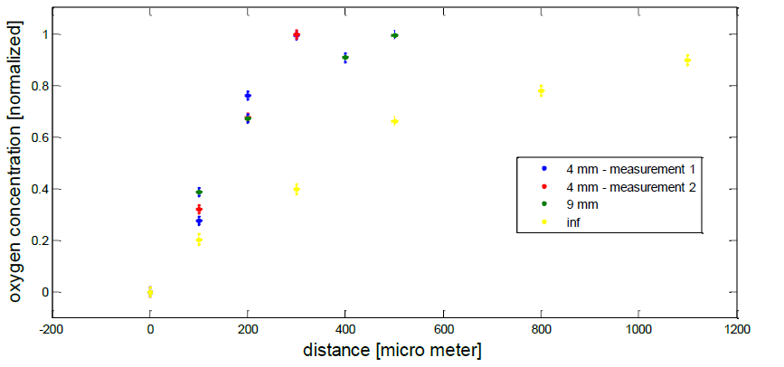
Figure 1. Oxygen concentration around the egg as a function of distance under different flow regimes. As flow sources distance increases the gradient becomes less steep. When flow source is close to the egg (blue and red dots) oxygen concentration increases more rapidly compared to when flow source is very remote (yellow dots). This means that under low flow speed oxygen consumption is lower.

Figure 2: Feeding rates and capture efficiencies sharply increased as larvae grew. (a) Feeding rate for 3 age groups, 8, 13 and 23 DPH (corresponding to total lengths of 4.4 mm, 5.9 mm, 9.8 mm, and Re of 30, 60 and 150, respectively). Letters above each bar represent post-hoc test results (Tukey HSD, p < 0.01). (b) Capture success was age-dependent (linear regression, R2=0.88, P=0.05). Capture success was defined as the % of strikes in which food remained in the mouth after mouth closing, divided by the total number of feeding attempts (n=138, with a minimum of 10 attempts per group). Error bars are 95% binomial confidence intervals.

Figure 3: Example of dynamic scaling of larvae used to separate the effects of size from other ontogenetic effects. Larvae immersed in viscous solutions encountered a hydrodynamic regime equivalent to that encountered by smaller larvae in untreated water. For example, water containing 4% Dextran will be 1.8-fold more viscous than water alone, such that a 10 mm larvae feeding in such waters would experience a Re regime equivalent to that of a 5.3 mm larvae in untreated water.

Figure 4: (a) The effect of dynamically scaled size on larval feeding rates. Feeding rate (rotifers consumed per hour) significantly increased with the dynamically-scaled size of the larvae (F_{(2,18)}= 79.4, p < 0.0001), whereas no significant effect of age was observed (F_{(2,18)} = 79.4, p > 0.40). A similar correlation was observed betwen feeding rates and Re (R²=0.83; data not shown). (b) Feeding rates generated by an encounter rate model (dashed lines) were compared to measured feeding rates (solid lines) for all dextran treatments in the three larval age groups (8 DPH, red; 13 DPH, blue; 23 DPH, green). Normalized feeding rates, relative to the maximal average feeding rate in each age group for all viscosity treatments, decreased with increasing water viscosity (F_{(5,36)} = 75.6, p < 0.0001). However, the decrease in the observed feeding rates with increasing viscosity was significantly stronger than expected based on the encounter rate alone (F_{(5,36)} = 75.6, p < 0.0001). Slope comparisons revealed that viscosity-mediated effects on suction performance accounted for ~75% of the decrease in feeding rates (major axis, R²=0.74, p < 0.0001, slope= 2.52).
Figure 5. Prey-capture distance as a function of larval age. Relative distances (in maximal gape diameters; left panel) and absolute distances (in mm; right panel) of prey capture were measured for three larval age groups (8, 12, and 22 DPH, feeding in Re 30, 60 and 150, respectively). Red bars represent unsuccessful attempts while green bars represent successful attempts. Capture distance increased with larval age, with no significant difference noted between missed strikes of 8 DPH larvae and successful strikes of 12 DPH larvae. Similarly, no significant difference was observed between missed strikes of 12 DPH larvae and successful strikes of 22 DPH larvae (Tukey HSD, p < 0.002).

Figure 6. Discriminant analysis of strike kinematics recorded for dynamically scaled and non-scaled 13 and 22 DPH larvae. Strikes clustered according to dynamically scaled size (and Re), rather than to age. Columns and similar colors represent clusters determined by the discriminant function, while rows correspond to groups pre-defined by age and dextran (Dex) concentration (left axis). Square size represents group size. The results of MANOVA pairwise comparisons performed on a principal components analysis of strike kinematics are summarized along the right axis.
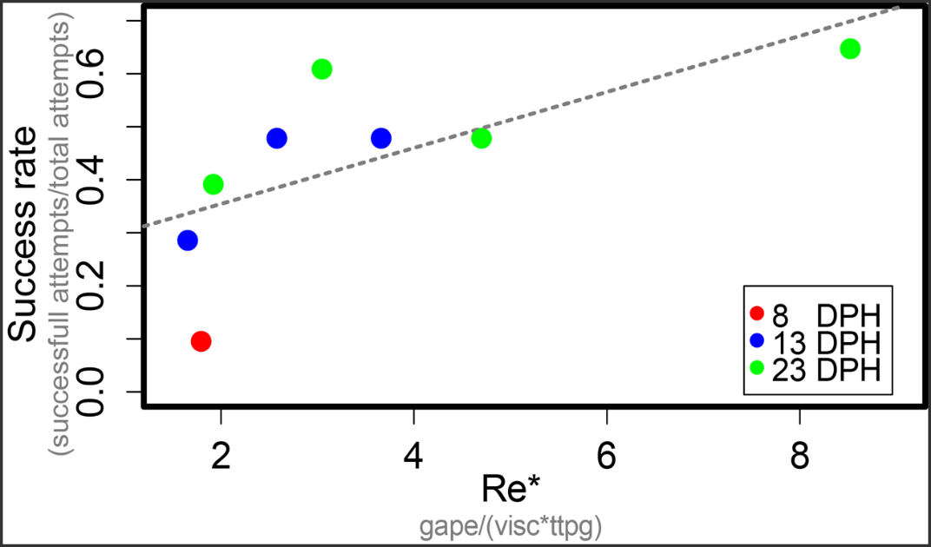
Figure 7: Reynold values (of mouth during feeding) determine feeding success rate. Based on AIC scores (using model selection), my results show that Re* (X axe) and normalized feeding distance are good predictors of feeding success, while larval size and age were dropped from the best model (permutative linear model, F_{(2,5)}= 9.5 ,r²= 0.71,p=0.019).

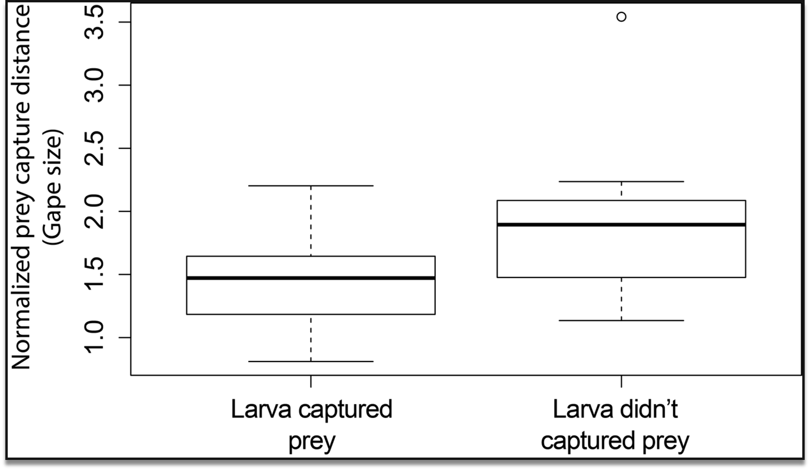
Figure 8: When comparing between failure and success normalized feeding distance is significant; as prey capture distance increases the probability to succeed decreases; Wilcoxon signed rank test, V=34 p=0.012

