BERKO award 2016-2017

High-resolution temporal dynamics of planktonic foraminifera assemblages and compositions in the modern Gulf of Aqaba waters

Submitted by: Natalie Chernihovsky
The Hebrew University of Jerusalem
The Interuniversity Institute for Marine Sciences in Eilat
Supervisors: Dr. Adi Torfstein
Dr. Ahuva Almogi-Labin
Abstract
Planktonic foraminifera (PF) are one of the most common calcareous groups of pelagic organisms in the open ocean. The global and regional distribution dynamics of these unicellular organisms are controlled by oceanographic and climatic conditions, and has been shown to follow temporal cycles that range from seasonal to monthly timescales. Hence, PF provide a highly sensitive proxy of open water column environmental conditions, and their accumulated carbonate shells in deep ocean sediments are often used to reconstruct the history of the oceans over geological timescales.
Previous studies in the northern Gulf of Aqaba (GOA) have investigated PF standing stocks and species assemblages obtained from plankton tows and deep-sea cores; yet, information of the population dynamics is still very poorly constrained, particularly in the context of high resolution temporal changes (annual, seasonal, monthly and daily). Similarly, there is currently no knowledge of the temporal size or composition variations of PF in the GOA.
Using the first continuously deployed array of sediment traps in the GOA, this work aims to characterize PF fluxes, species assemblages, distribution and sedimentation rates, and quantify their reproductive life cycles at high temporal resolution. PF fluxes to the sea floor will be characterized and have important implications for the reconstruction of paleo-productivity and paleo-oceanography in the northern GOA through the upper Holocene.
Preliminary results, from samples collected between January 2014 and February 2016, demonstrate strong seasonality of PF fluxes, whereby low fluxes are observed during the spring-summer months, gradually rising to higher fluxes during the autumn-winter (fig. 1). This pattern follows the overall mass fluxes and the development of the mixed layer depth, but does not correspond to previous studies of the PF standing stock in the GOA from 1974-1976, possibly reflecting a change in the PF population over recent decades; indeed, a notable example is the total absence of G. sacculifer from the recent species assemblage (fig. 2), despite the fact that it used to be the most dominant species 40 years ago. These discrepancies might indicate a change in the PF population over recent decades but may also stem largely from our poor knowledge of the PF distribution patterns in the GOA, emphasizing the importance of the current study. Moreover, the results indicate that the most significant PF size fraction in terms of mass and fluxes is in the range of 63-125µm, which has not previously been studied in this area, and only very rarely in comparable studies around the world.
Future results, compiling investigating PF population dynamics and their relation to environmental conditions alongside quantify their reproductive life cycles at extremely high temporal resolution will improve our understanding of the connection between overlying ocean conditions and the sedimentary record through PF studies, and thus to reconstruct the history of the oceans in general and that of the GOA and Red Sea in particular.

Figure 1. Monthly average fluxes of planktonic (purple), benthic (green) foraminifera (# m⁻² d⁻¹) and primary production (orange, mg C m⁻² d⁻¹, integration of the water column) on the primary axis; and average mass flux (blue, g m⁻² d⁻¹) on the right y-axis, during January 2014 - February 2016.
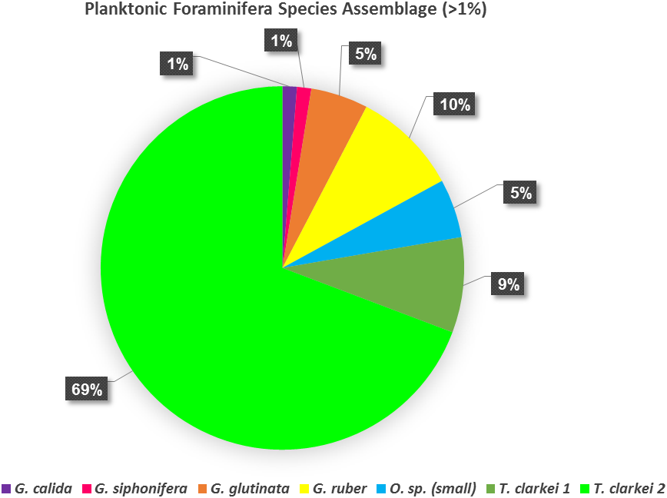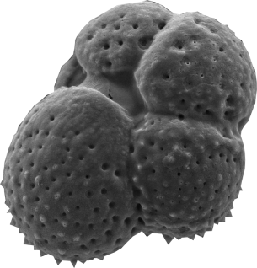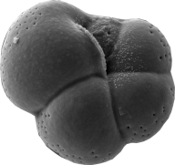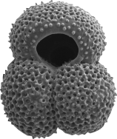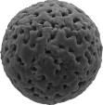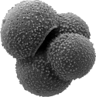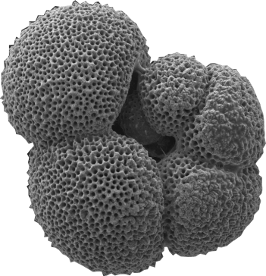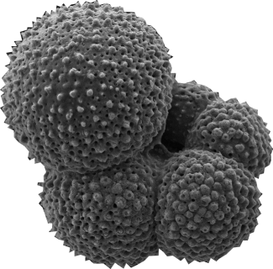

Figure 2. Planktonic foraminifera species assemblage (species constitute >1%) during January 2014 - February 2016.

