The Interuniversity Institute for Marine Sciences in Eilat (IUI)
Visitor Information Handbook

Version: January 2016
(Subject to change without notice)

On behalf of the IUI, we welcome you to our campus.
This handbook contains general information and common visit-related questions.

Wikipedia has useful general background information about Eilat:
https://en.wikipedia.org/wiki/Eilat
http://wikitravel.org/en/Eilat
http://www.eilat-guide.com/

Weather: Eilat has warm and almost rainless winters. Winter temperatures are usually between 11–23°C but may be as low as about 5°C and windy. See climate data for Eilat at https://en.wikipedia.org/wiki/Eilat.

The IUI website in English:
http://www.iui-eilat.ac.il/Default.aspx
http://www.iui-eilat.ac.il/Info/Contact.aspx (has a map)

International Dialing Code for Israel: 972

Time Zone: GMT + 2

Currency: New Israeli Shekels (NIS). Examples of Israeli coins and banknotes can be seen at: https://en.wikipedia.org/wiki/Israeli_new_shekel.

IUI Office Phone Number: 972-8-6360111 (from overseas); 6360111 (within Eilat and Negev); 08-6360111 (from outside the Negev region).

IUI Fax: 972-8-6374329

IUI Secretariat Email: iui@mail.huji.ac.il

Office Hours: Administrative offices are open Sunday-Thursday between 08:00-16:00.
The weekend in Israel is Friday/Saturday.

National/Religious Holidays: From 1st January - 30th September 2016, the IUI will be closed on the following dates: 24th March, 25th March, 22nd-30th April, 11th May, 12th June, 14th August.

Passport: You must be in possession of a passport that is valid for six months beyond the period of your visit. Keep a copy of the IUI invitation letter with you in case airport passport control or security asks you questions about the purpose of your travel to Israel.

Entry Visa: There are two main visas used for students and visitors at IUI. Stays under 3 months are normally obtained on arrival at passport control as a standard tourist entry visa.
The following website indicates which countries require an Israeli visa in advance of travel:
http://mfa.gov.il/MFA/ConsularServices/Documents/VisaRequirements-Tourists.pdf
Foreigners who will be here longer than 3 months should obtain an A/2 student visa (including post-docs). This visa must be obtained before arriving to Israel.

Such visas can be extended upon an application submitted in person to the Ministry of the Interior office in the town of your sponsoring university. An appointment is required. Each university has a foreign student liaison that should be able to help you gather the appropriate paperwork and make an appointment. If you are mainly based in Eilat, it may be possible to renew your visa from the Ministry office located in the building of the main post office in the city center. The opening hours are Sunday-Tuesday and Thursday: 08:00-12:00. It is recommended to start the renewal process 3 months before visa expiry.

The documents required for a student visa renewal include:
- your passport;
- a passport photo;
- a fee;
- an application form (available at the Ministry);
- valid confirmation that you are a student at your university for the relevant academic year (for The Hebrew University of Jerusalem you can print the student confirmation from the website).
- list of courses and grades of the previous academic year;
- confirmation that you are receiving a scholarship (or a salary);
- possibly a document proving that the IUI is an official “part” of your home university;
- possibly a letter stating that you have where to live in Eilat;
- make sure to ask for a multiple-entry visa if you plan to leave Israel and come back during the time when the visa is valid. An additional fee is required;
- if your student visa has already been renewed for several years in a row, other letters/documents might be required.

Flights to Eilat: In general your flight will consist of flying to Ben Gurion International Airport (TLV), which is about 10 km from Tel Aviv, and then an internal flight from Ben Gurion airport to Eilat’s Hozman Airport (ETH).

International arrivals land in “Terminal 3” of Ben Gurion Airport. After going through passport control, collecting your suitcases and passing through Customs, you are in the arrivals hall. This hall has currency exchange counters, automatic currency cash machines, etc.

For Eilat flights, you must transfer to Terminal 1. In the arrival hall turn to your right and take “Exit 01”. To the right there will be a sign for the free airport shuttle (orange color) to Terminal 1 (domestic flights). At Terminal 1 you go through security and then check in your baggage for the flight to Eilat.

There are 2 companies in Israel handling flights from Ben Gurion Airport to Eilat.

Israir: http://int.israirairlines.com/cat_domestic.asp
Arkia: http://www.arkia.com/flights-in-israel

Since these are separate flight tickets (ie. not code-sharing) to Israel and then to Eilat, you must allow enough time between flights for delays in arrival. We strongly recommend allowing 3-4 hours between arrival/departure.

In case flights to Eilat from Ben Gurion Airport are full, note that there is a small domestic airport located in northern Tel Aviv called Sde Dov with both Arkia/Israir flights to Eilat. However you must take a private taxi from Ben Gurion Airport at a cost of about NIS 170 and thus should allow 5 hours between arrival and departure time to Eilat.

For your return flight from Eilat to Ben Gurion airport, you arrive at Terminal 1 (domestic), collect your luggage, and then take the free shuttle bus (approx. every 15 minutes) to Terminal 3 (international) (about 7 minutes). There will be a security check before the flight check-in. Accordingly, we strongly recommend about 4 hours from arrival at Terminal 1 and your connecting flight from Ben Gurion airport Terminal 3.

The flight from the airport to Eilat is quite spectacular in terms of landscape. The path flies over Jerusalem and then follows the Dead Sea to Eilat. We recommend a window seat on the right-hand side of the plane for flights in the morning and left-hand side for afternoon flights. For flights leaving Eilat, choose a window seat on the left-hand side for morning flights and right-hand side for an afternoon flight.

Getting from Eilat Airport to IUI Campus: Eilat is very small and the Eilat airport is situated right in the middle of the town. The IUI is about 7 km south of Eilat. After you collect your baggage, there are taxis at the exit. If you are staying in the IUI dorms, then tell the driver in English “The University Marine Center by the “Mitzpeh” and/or just show them the logo, below. A taxi-ride from the town center or the airport would cost about NIS 40-50 and can carry 3 or 4 passengers. If you arrive in Eilat before/after normal working hours, we will inform the IUI security officer. You just need to press the bell on the entry gate door. This may take a few minutes if the officer is doing his/her routine patrol of the IUI premises.

IUI Accommodation:
Your accommodation in Eilat will depend on your contract and host at IUI. You may be assigned a campus dorm room or a place in the IUI-owned apartment in the city center. Your assigned accommodation may be available for the duration of your stay (usually if less than 6 months) or may be temporary until you can find a permanent living arrangement. There is a fee for IUI accommodation. Karen Madmoni is responsible for the IUI dorms (karenm@mail.huji.ac.il; Tel: +972-8-6360125). In general, there will be from 3-4 people per dorm room but apartment rooms are 2 per room. Bed linen and blankets are provided. Rates are available from Karen.

No washing machines are available on campus but there are self-service laundromats in Eilat (see map). The cost is NIS 25 (four 5 shekel coins for washing, and two 5 shekels for drying; bring your own washing powder).

There are 2 IUI apartments in Eilat. One is at 1146 (Sheshet HaYamim Street), Apartment No. 4, building entrance “Alef”. All the buildings in the block have the same number (1146) but have different entrances. The Google map, below, shows the 1146 apartment location (yellow pin), and the photo shows the entrance (by the silver car). The entrance sign for the 1146 building is provided below. There is a supermarket on this street about 100 meters away.

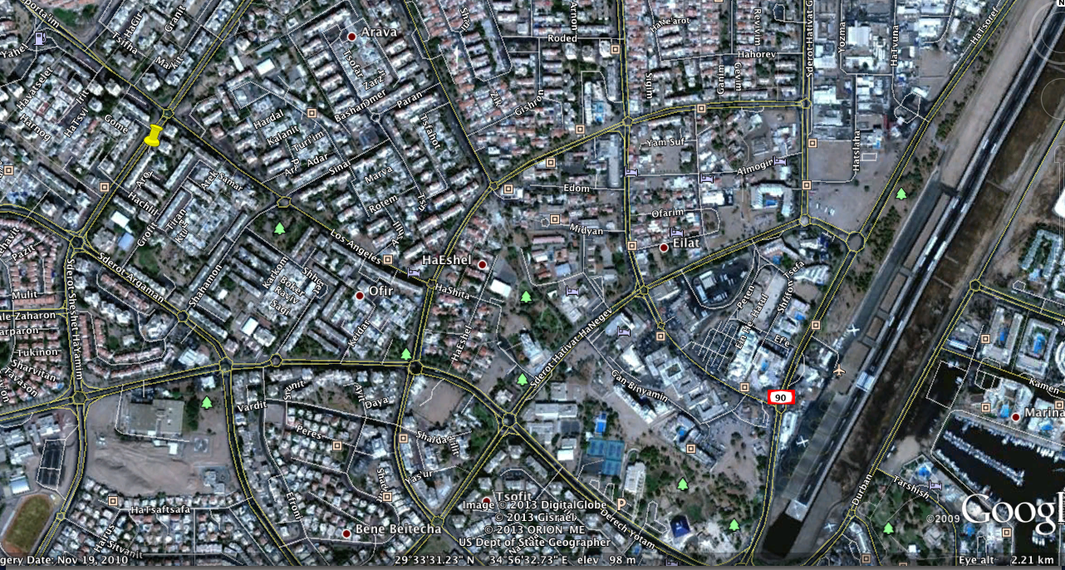
Yellow pin indicates Apartment 1146 on Sheshet HaYamim Street.

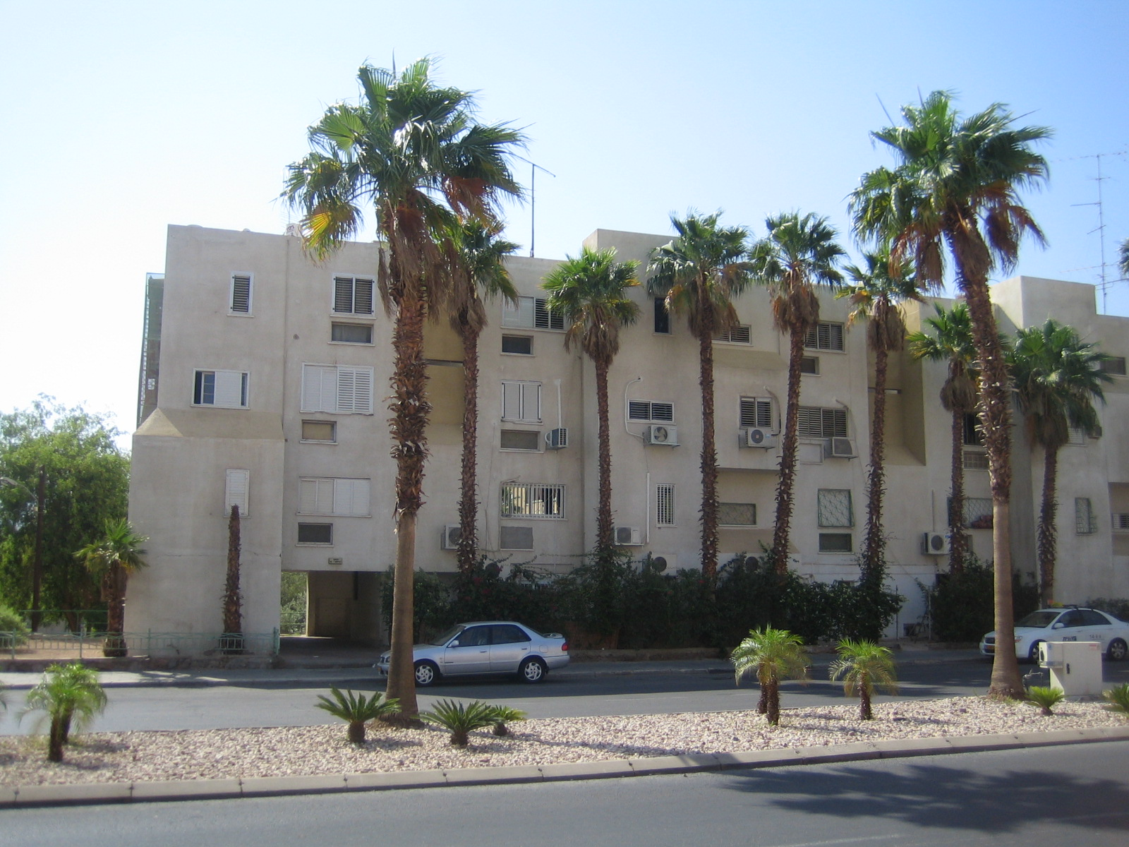
View of Apartment 1146 building on Sheshet HaYamim.
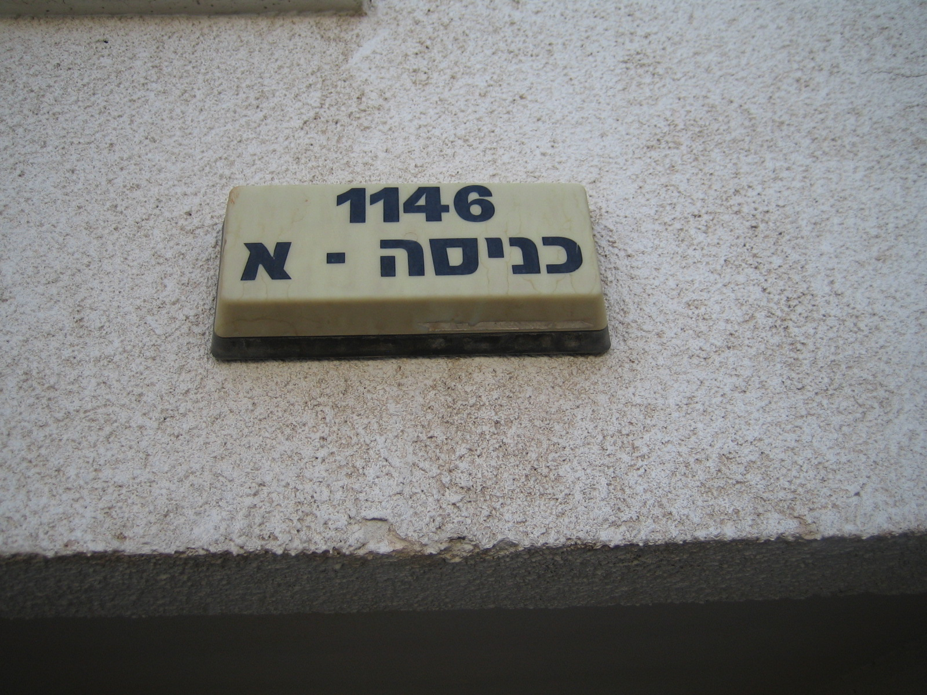

Hebrew entrance sign (entrance “alef”) of 1146 Sheshet HaYamim.

The second apartment is 603 on Eilot Street, Apartment No. 7 (see map below).

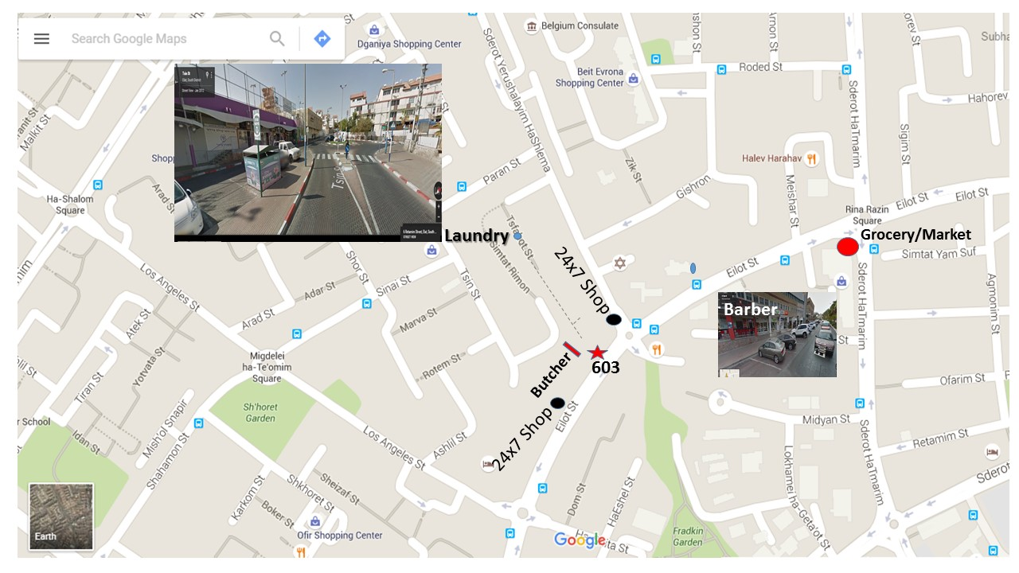
The closest grocery/supermarket near 603 is the Razin Shopping Mall, or you can use the 24/7 shops nearby (see map).

Both the dormitories and apartments have regulations.
See: http://www.iui-eilat.ac.il/Info/Regulations.aspx.

Meals: There is no cafeteria on the IUI campus, but both the dorms and apartments in town all have fully equipped shared kitchens. During your visit, meals can be prepared on your own or together with other students/visitors. The nearest restaurant/café from the IUI campus is about a 15 minute walk.

Private Accommodation: Being a foreigner, this may be complicated to find and arrange. Contracts are needed, usually advance payments, and the apartment may be represented by a real estate agency. Such agencies usually charge a 1-month commission. Your host may be able to help you.

IUI Telephone: Dorm rooms have phones for receiving incoming calls only. There are no public phones on the IUI campus. However, we advise you to bring a cell phone and buy a local Israeli SIM
card. In Eilat itself, hotels, and on the streets, there are public payphones that use telephone cards purchased from the post office. In addition, there are some private companies selling similar cards but with access codes required rather than direct dialing.

Cell phones: There are a different phone companies in Israel. Some of the most popular are HOT Mobile, Pelephone and Cellcom. Bring your passport, credit card, and an address. The plans vary from company to company and with differing costs. Payment is taken by standing order each month. Alternatively, you can buy a pre-paid SIM card and load funds to the phone (can be done at Post Offices).

IUI Computers and Internet (Wifi): There is wifi access on the IUI campus. You can arrange access after arrival. The IUI secretary will direct you to the IUI computer officer.

Electricity: Electricity in Israel is rated at 220V (220V-240V) 50Hz. Israel uses what is called a "H" type plug. This plug has two flat prongs that form a V-shape and a flat vertical grounding prong at the bottom. They are rated at 16A. The sockets are shaped as to also accommodate type C plugs as well. See: http://www.megavolt.co.il/Tips_and_info/visitor.html.

Diving and Diving Insurance for the IUI: The IUI website contains information and regulations regarding diving at the IUI and insurance requirements. See: http://www.iui-eilat.ac.il/Info/Regulations.aspx. In summary, you will need to provide the IUI Diving Officer with a health certificate, diving certificates, diving insurance as required for the IUI, and must do a check dive.

Insurance: You are required to obtain full health/travel insurance. It must cover the full period from the day of your home departure to arrival day of return, cover pre-existing medical conditions, and include world-wide travel assistance and emergency air transportation services. This is a private cost.

Access to IUI Laboratories: All new users will be given a tour of the labs, safety aspects and are required to view an online safety video and do an online lab safety self-test.

Bus Schedule from/to IUI and Eilat: Bus #15 goes from Eilat to the IUI; cost is about NIS 5. The bus stop for the IUI is next door to an Underwater Observatory (“Mitzpeh” in Hebrew). On the return journey from IUI to Eilat, the bus number is 15 or 16. The bus company (“Egged”) serves cities and also operates intercity bus transport throughout Israel. Their website in English is http://www.egged.co.il/Eng.

For Eilat/IUI bus service info and timetables, you should click on “Plan a trip”, type in Eilat as the Departure City, and then beneath it view the scroll-down list of sites within Eilat (for example Central Bus Station). For IUI, type in Eilat for “Destination” and then “The Underwater Observatory – Bus 15”.

Workers Bus to/from Eilat: There is a separate bus line specifically for Eilat workers/residents. Details on request.

The Eilat Tourist Information Center: (Tel. 08-6309111; zipiv@tourism.gov.il) is located at Bridge House, a small building on the North Beach Promenade.

Banks, Currency Conversion: No need to obtain Israeli currency before arriving in Israel. Ben Gurion Airport has a bank currency changing kiosk and there are automatic cash dispensers that work with most international credit cards. Note that withdrawing funds from the automatic cash dispenser will give you a far better exchange rate. Israel has numerous currency exchange kiosks in every city that provide good currency rates and are commission-free (banks charge a fee). The price advertised is exactly what you will get per unit of currency. Almost all stores accept credit cards. Banks are located on Tmarim Street, opposite the airport in town.

Bank Account: Should you be planning a long stay in Eilat and/or expect to receive scholarship funds or foreign remittances, then you must open a bank account. You will need your passport and the small paper entry visa given to you when you went to Passport Control at Ben Gurion Airport. All transactions will require that you bring your passport.

Opening an account can take a full morning. All paperwork is in Hebrew, they walk you through the documents, and you will receive a copy of what you signed, but it will be in Hebrew. Be sure to specify you are a student (even if you’re a post-doc), as you may be entitled to service charge fee reductions. The bank will also issue you an ATM card and you may also order cheque books.

An alternative to banks is to open an account with the Israel Postal Bank, which operates in Post Office branches. Accounts can be set up and managed in the Post Office located on the ground floor of the Egged shopping centre off Tmarim Street. You can request a cash card and cheque book.

Credit Cards: All major credit cards can be used in Israel (Visa, Mastercard, American Express, etc.) and almost all stores, restaurants, etc., accept them.

Eilat Residence Card: If you plan to be in Eilat for 3 months or more, it may be worthwhile to get this card and take advantage of special prices when dining, shopping, or even travelling. The IUI secretary can provide you with the required letter. Go to the Eilat Municipality building (off Hatmarim Street), during regular business hours and pay the NIS 25 fee.

Recommended Items to Bring:
- Appropriate seasonal clothing
- Backpack or shoulder bag
- Appropriate footwear to wear on the boat (closed toe)
- Sunscreen
- Sunglasses
- Hat
- Towel
- Emergency contact phone numbers (parents and physician).

Medical: Only some general information is provided here and may change at any time. Should you need to see a Doctor in Eilat, there are 2 options. The first is to go to one of the three Health Fund Clinics (Leumit, Maccabi or Clalit). You will be charged a fee for the initial check and additional fees for each service (x-ray, stitches, etc). Receipts and a medical report will be provided. Some clinics may also offer emergency dental services.

At the moment, operating hours are:
Leumit: 12 Gan Binyamin Street (Tel: 08-6306200)
Sunday, Monday, Tuesday, Thursday: 08:00-13:00 and 16:00-19:00
Wednesday: 08:00-13:00

Maccabi: 39 Tmarim Boulevard (Tel: 08-6364848)
Sunday, Wednesday, Thursday: 08:00-12:00 and 16:00-18:00
Monday, Tuesday: 08:00-12:00

Clalit: 24 Ha’Agas Street (Tel: 08-6336555)
Sunday, Tuesday, Thursday: 07:30-13:00 and 16:00-19:00.
Monday, Wednesday: 07:30-16:00.

In an emergency or outside Health Fund hours, you may go to Yoseftal Medical Center (Hospital), Yotam Road: Reception Tel: 08-6358011; Clinic Office Tel: 08-6358025. There will be additional fees for each service (x-ray, stitches, etc). Receipts and a medical report will be provided.

